PROJECT REPORT
Bank Loan Eligibility Checker

NAME : KUSHAL VERMA SUBJECT : OBJECT ORIENTED PROGRAMING
UID : 24BCA10152 SUBJECT CODE : 24CAH-201
SECTION : 24BCA2A DEPARTMENT : UIC

Table of Contents
S.No | Content | Page No.
1 | Introduction | 3–4
2 | Abstract | 5-6
3 | Objective | 7-8
4 | Problem Definition | 9-10
5 | System Design | 11-15
6 | Techniques | 16-18
7 | Challenges | 19-20
8 | Flow Chart | 21
9 | Output | 22
10 | Acknowledgment | 23
11 | Conclusion | 24-25
12 | Reference | 26

- Introduction
- In the financial sector, loan approval is one of the most critical processes carried out by banks and lending institutions. Every day, thousands of individuals apply for personal loans, home loans, education loans, and business loans. To maintain financial stability and reduce the risk of defaults, banks must evaluate each application carefully before making a decision. Traditionally, such evaluations were done manually by loan officers, but with advancements in technology and the need for faster processing, automated decision-making systems have become essential.
- A Loan Eligibility Checker is a simplified model of these real-world banking systems. It examines an applicant’s details—such as age, employment status, monthly income, credit score, existing financial obligations, and the loan amount requested—and determines whether the applicant is capable of repaying the loan. These parameters help in estimating the applicant’s financial stability and reduce the chances of the bank facing losses.
- This project, Bank Loan Eligibility Checker, is developed using the C++ programming language. C++ is known for its speed, reliability, and support for structured and object-oriented programming, making it an ideal choice for implementing logical decision-making systems. The project follows a modular approach, where user inputs are collected, validated, and processed through a series of functions that apply bank-defined eligibility rules. These rules include age limits, minimum income requirements, credit score thresholds, debt-to-income ratio analysis, and restrictions on the maximum loan amount based on income levels.
- The primary goal of this project is to demonstrate how a rule-based financial decision system can be built using C++. The program not only checks whether the applicant qualifies for the loan but also provides clear reasons for rejection, helping users understand financial criteria better. This makes the project educational, practical, and aligned with real-world banking operations.
- In addition to teaching programming logic, the project also helps students understand important financial concepts such as EMI (Equated Monthly Installment) calculation, interest rate determination, and debt-to-income ratio analysis. These concepts are crucial in the banking domain and provide valuable insights into how lending decisions are made.
- Overall, the Bank Loan Eligibility Checker project highlights the integration of computer programming with financial decision-making. It showcases how technology can streamline banking operations, improve accuracy, and make loan processing faster and more transparent. This project can be further extended into a more advanced system by adding a graphical user interface (GUI), database connectivity, and more complex lending rules.

- Abstract
- The process of evaluating and approving loan applications is a vital function of every financial institution. Banks must ensure that borrowers have the capability to repay the loan within the agreed tenure to minimize financial risk and maintain stability. In modern banking environments, automated loan assessment systems are widely used to improve accuracy, reduce processing time, and avoid human errors. This project, titled Bank Loan Eligibility Checker, presents a simplified yet effective model of such a system using the C++ programming language.
- The primary objective of this project is to design and implement a rule-based algorithm that determines whether an applicant is eligible for a loan based on predefined criteria. The system collects essential input parameters such as the applicant’s age, monthly income, employment status, credit score, existing EMI obligations, requested loan amount, and loan tenure. These inputs are then processed through a series of checks including minimum income requirements, age limits, credit score thresholds, allowable debt-to-income ratio (DTI), and maximum loan amount permitted relative to annual income. Using these criteria, the program evaluates the applicant’s financial capability to repay the loan.
- A significant feature of the project is the computation of the Equated Monthly Installment (EMI) using the standard mathematical formula, along with the estimation of the interest rate based on credit score categories. This gives users a realistic understanding of how EMI and interest affect loan eligibility decisions. The system not only provides a final decision — either Approved or Rejected — but also displays detailed reasons for rejection, which increases transparency and makes the tool educational for users.

- Developed in C++, the project showcases key programming concepts such as modular design, functions, structures, conditional decision-making, input validation, and formatted output. It serves as an excellent example of how financial logic can be implemented using programming principles. The simplicity, accuracy, and clarity of the system make it suitable for academic purposes, beginners’ learning, and demonstration in project presentations.
- The Bank Loan Eligibility Checker thus acts as a practical simulation of a real-world banking decision system, bridging the gap between theoretical financial concepts and actual coding implementation. The project can be extended to include a graphical user interface, database integration, or more advanced analytics, making it a scalable foundation for future enhancements.

- Objective
- The primary objective of this project is to develop a clear, organized, and modular C++ program capable of determining loan eligibility based on user-provided financial and personal details. The project aims to demonstrate how C++ can be used to design a structured system where each part of the logic—data collection, validation, rule checking, and output generation—is handled in a systematic and readable manner. By dividing the program into multiple functions and modules, the project ensures better maintainability, easier debugging, and improved clarity for learners.
- A major goal of the system is to implement realistic loan eligibility rules that reflect common banking standards. These rules include minimum and maximum age requirements, acceptable income thresholds, employment status verification, minimum credit score limits, and the debt-to-income (DTI) ratio calculation. By applying these checks, the system mirrors real-world loan assessment processes where financial institutions evaluate an applicant’s repayment capability before approving a loan. The inclusion of such practical rules makes the project more meaningful and educative for students.
- Another important objective is to calculate the Equated Monthly Installment (EMI) using the standard mathematical formula and estimate the interest rate based on the applicant’s credit score. The project uses this EMI value to generate a clear decision report that specifies whether the applicant is eligible or not eligible for the requested loan. If the application is rejected, the system provides a list of reasons explaining the failure of each eligibility criterion. This creates transparency and helps users understand their financial standing in a detailed manner.

- Finally, the project aims to strengthen the learner’s understanding of fundamental C++ programming concepts, including the use of structures or classes to store related data, functions to separate program logic, loops for input validation, conditional statements for decision-making, and formatting techniques to present output neatly. Through this project, students gain practical experience in applying these concepts to a real-world problem, making it an excellent learning tool for academic purposes.

- Problem Definition
- Financial institutions receive numerous loan applications daily, and each application must be evaluated to determine whether the borrower has the capacity and reliability to repay the loan. Manual evaluation is slow, prone to errors, and inconsistent. Therefore, there is a need for an automated and rule-based system that can quickly analyze applicant data and determine eligibility. The Bank Loan Eligibility Checker aims to address this problem using a computational approach implemented in C++.
- The core problem is to design a system that can analyze applicant data and decide whether a loan request should be approved or rejected based on simplified and predefined banking rules. These rules represent typical criteria used by real banks to assess a borrower’s financial stability and creditworthiness.
To accomplish this, the program must evaluate several key factors:
- Minimum and Maximum Age Limits
- Banks typically lend only to individuals within a specific working-age range. The system must ensure that the applicant’s age falls within the defined boundaries. Applicants below the minimum age lack financial independence, while those above the maximum age may have reduced repayment capacity. If the applicant does not meet this age criterion, the system must record this as a reason for rejection.
- Minimum Monthly Income Requirement
- Income plays a crucial role in determining whether a person can manage regular loan payments. The system must check if the applicant’s monthly income meets the minimum required threshold. Applicants earning less than the set limit may not have sufficient financial capability to repay the loan, thereby resulting in ineligibility.

- Minimum Credit Score Standard
- A credit score reflects a person’s credit history, repayment behavior, and financial discipline. The system must verify whether the applicant’s credit score meets the minimum acceptable standard. A score below the threshold indicates higher risk, making the applicant unsuitable for loan approval.
- Maximum Allowed Debt-to-Income (DTI) Ratio
- The Debt-to-Income ratio measures how much of the applicant’s income is already committed to existing loans, including the new proposed EMI. The system must ensure that after adding the calculated EMI of the requested loan, the applicant’s DTI ratio does not exceed the defined maximum limit. A high DTI suggests that the applicant is financially overburdened and poses a higher risk of default.
- Loan Amount Limit Based on Annual Income
- Banks usually impose a cap on how much a person can borrow based on their annual income. The program must check whether the requested loan amount falls within the allowed multiple of the applicant’s annual income. If the loan amount exceeds the permissible limit, the system should flag this as a violation.
- Provide Clear Reasons for Rejection
- If the applicant fails any of the above eligibility checks, the system must not only reject the application but also provide specific reasons for the rejection. This ensures transparency and helps the user understand which criteria were not met.

- System Design
The system design defines the overall structure, major components, data organization, and the internal workflow of the Bank Loan Eligibility Checker. The project follows a modular approach, ensuring that each task—data collection, financial calculation, eligibility checking, and result generation—is handled by a separate component. This improves readability, maintainability, and scalability of the program.
- High-Level Modules
1. Input Module
The Input Module is responsible for collecting all necessary information from the user. This includes age, monthly income, credit score, employment status, existing EMI obligations, loan amount requested, and loan tenure.
The module also performs basic input validation, such as ensuring that values are positive, within realistic limits, and in the correct format. This prevents invalid or corrupt data from passing into the system.
2. Rule Engine
The Rule Engine is the core logic component of the system. It applies a set of predefined bank rules to determine whether the applicant is eligible for a loan.
Rules include:
- Age limits
- Minimum income requirement
- Minimum credit score
- Maximum permissible Debt-to-Income (DTI) ratio
- Loan amount cap compared to annual income
For each rule that fails, the system adds a specific rejection reason to the Decision object. The Rule Engine ensures transparent and rule-based decision-making.
3. Finance Module
This module performs the financial calculations required for evaluating the loan request.
Key functions include:
- EMI Calculation using the standard mathematical formula:
$$EMI=\frac{P⋅R⋅(1+R)^{N}}{(1+R)^{N}-1}$$
where P = principal, R = monthly interest rate, N = tenure in months.
- DTI (Debt-to-Income) Calculation:
After the EMI is computed, the DTI ratio is calculated:
$$DTI=\frac{\text{existing EMI}+\text{new EMI}}{\text{monthly income}}×100$$
The module also assigns an interest rate based on credit score bands, using a simplified scheme instead of an actual credit bureau model.
4. Output Module
The Output Module generates and prints a detailed decision report.
The report includes:
- Applicant summary
- Calculated EMI
- DTI value
- Final decision (Approved / Rejected)
- If rejected: list of exact reasons
- Optional: a simple amortization note (e.g., loan amount, tenure, and total payable amount)
This module ensures that the user receives a clear, readable, and helpful result.
- Data Structures
To keep data organized and accessible, two main structures are used:
1. struct Applicant or class LoanApplicant
Holds all key details of the user, such as:
- age
- monthly income
- credit score
- employment status
- existing EMI
- loan amount requested
- loan tenure
- assigned interest rate
This structure represents the core data model for applicant information.
2. struct Decision
Stores the results of eligibility evaluation:
- bool isEligible — final approval status
- double emi — calculated EMI
- vector<string> reasons — list of rule failures
- double dti — final calculated Debt-to-Income ratio
This clean separation ensures the Rule Engine and Output Module can easily access decision details.

- System Flow
The internal workflow follows a clear step-by-step pipeline:
- Collect applicant details through the Input Module.
- Validate the input values to ensure correctness.
- Compute the EMI using the Finance Module based on loan amount, tenure, and interest rate.
- Calculate the new DTI ratio, combining existing obligations with the new EMI.
- Run eligibility rules in the Rule Engine.
  - Each failed rule adds a reason to the Decision object.
- Output the final decision through the Output Module.
  - If eligible: show approval summary
  - If not eligible: show detailed rejection reasons
This flow ensures logical and consistent processing.
- Assumptions & Simplifications
To keep the project suitable for a student-level implementation, certain simplifications are made:
1. Simplified Interest Rate Model
Interest rates are assigned based on broad credit score ranges (e.g., >750 = low interest, <600 = high interest).
This avoids complex risk-based calculations.
2. No Credit Bureau Integration
The system does not access real credit databases.
All credit-related checks are rule-based and approximate.

3. All Values Assumed in INR or Generic Currency
The program assumes monetary inputs are monthly values and uses a consistent currency format throughout the calculations.
4. EMI Calculations Ignore Extra Charges
Real EMI calculations include processing fees, insurance, and GST.
These are not included for simplicity.

- Techniques Used
The project utilizes a wide range of C++ programming techniques to ensure that the loan eligibility checking system is accurate, modular, readable, and efficient. These techniques reflect real-world software development practices and make the project a strong academic example of structured programming in C++.
1. Modular Program Design
A major technique used in this project is modular design, where the entire program is divided into separate functional units. Each module—such as the input module, rule evaluation engine, EMI calculation function, and output generator—is implemented as an independent function or class method. This separation of responsibilities improves readability, reduces code duplication, and simplifies debugging. If a change is required in any part of the system, such as updating interest rate rules or changing eligibility criteria, it can be modified without affecting other modules.
2. Use of Data Structures (struct / class)
The program uses custom data structures to store and handle applicant information efficiently. A struct Applicant (or a class LoanApplicant) is used to group related fields such as age, monthly income, credit score, requested loan amount, and existing EMIs. This approach keeps all relevant data organized in a single unit, improving maintainability. Another structure, Decision, holds the outcome of the eligibility evaluation, including the EMI amount, approval status, and a list of reasons for rejection. These structures demonstrate how object-oriented principles can be applied even in relatively simple programs.
3. Financial Mathematics – EMI Calculation
The program incorporates real financial mathematics by using the standard EMI formula:
$$EMI=\frac{P×R×(1+R)^{N}}{(1+R)^{N}-1}$$
where P is the principal amount, R is the monthly interest rate, and N is the loan tenure in months.
This formula is implemented carefully using floating-point precision management to ensure accurate results. Applying financial formulas in a C++ program demonstrates the practical use of mathematical functions and real-world computation.
4. Input Validation Techniques
Reliable input handling is critical for any program. This system implements robust input validation using loops (while) that repeatedly ask the user for valid input if incorrect, negative, or non-numeric values are provided. Techniques such as cin.fail(), clearing the input buffer, and retrying inputs help ensure program stability and prevent runtime errors. This is especially important in simulations involving financial data, where invalid values can break calculations or produce misleading results.
5. String Handling and Output Formatting
To ensure clarity and professional presentation, the project uses several C++ formatting techniques. Tools such as ostringstream help construct well-formatted multi-line messages. The program also uses manipulators from the <iomanip> library, such as fixed, setprecision, and column alignment methods, to display numeric results neatly, especially for EMI values, DTI ratios, and summary tables. This enhances user experience and makes the output look like a real banking report.

6. Conditional Logic & Rule Evaluation
The eligibility rules are implemented using nested and modular conditional checks (if, else if, else). Each rule—age limit, credit score threshold, income minimum, and maximum allowable DTI—is evaluated separately, and failure reasons are stored in a vector. This approach ensures transparency and flexibility, allowing easy modification or addition of rules in the future.
7. Use of Mathematical and Utility Libraries
The project uses standard C++ libraries like <cmath> for mathematical functions (e.g., pow() for EMI calculation), <vector> for storing rejection reasons dynamically, and <string> for handling user messages. These libraries make the program more efficient and versatile.

- Challenges
Developing the Bank Loan Eligibility Checker involved several challenges that required careful consideration, especially since the goal was to balance real-world accuracy with simplicity suitable for a student-level C++ project. These challenges influenced the design choices, rule formulation, and structure of the entire program.
1. Creating Realistic but Educational Eligibility Rules
One of the primary challenges was designing eligibility rules that were realistic enough to reflect how banks assess loan applications, yet simple enough for students to understand and implement. Real banking systems use complex credit algorithms, dynamic interest rate calculations, risk scoring models, and data fetched from external databases. Including such advanced mechanisms would make the project unnecessarily complicated. Therefore, the challenge was to identify core rules—age limits, minimum income, credit score thresholds, DTI ratio, and loan-to-income limits—that strike a balance between real-world relevance and academic simplicity. Ensuring these rules were both practical and easy to implement required thoughtful simplification.
2. Handling Unusual or Invalid Inputs Robustly
Another key challenge involved ensuring that the program could handle unusual, extreme, or invalid inputs without crashing. For example, inputs such as zero or negative income, extremely large loan amounts, negative credit scores, or non-numeric entries could disrupt calculations like EMI or DTI. Without proper input validation, these issues could lead to runtime errors or misleading eligibility decisions. Designing validation loops that detect and reject such inputs—while guiding the user to enter correct values—required attention to detail. The challenge also included managing input buffer clearing to prevent endless loops caused by cin failures.
3. Balancing Realism With Student-Level Simplicity
Another challenge was achieving the right balance between real-world financial modelling and the constraints of a beginner-to-intermediate C++ project. Actual loan evaluation involves extensive datasets, customer history, credit bureau data, probabilistic models, and market-based interest adjustments. Implementing such complexity would not only overwhelm students but exceed the scope of a typical academic project. The challenge was to extract key elements—like EMI calculation, credit score ranges, and debt-to-income ratio—and simplify them into a static, rule-based model that is still meaningful. This ensures that students learn the logic behind loan assessment without being burdened by advanced financial or machine learning concepts.
4. Maintaining Clear Output and User Understanding
Presenting eligibility results in a clear and user-friendly way was also challenging. The output needed to show EMI, DTI ratio, approval/rejection status, and detailed reasons for ineligibility. Managing string formatting, decimal precision, and organized message layout required careful design. Ensuring that the final output looked like a professional decision report—while still being generated by simple C++ console output—required proper use of formatting libraries and consistent wording.
5. Ensuring Modular and Maintainable Code
Since the project showcases good programming practices, maintaining modularity throughout the design was essential. The challenge was to divide the program logically—input module, rule evaluation engine, EMI calculator, output module—without letting functions depend excessively on each other. Modular code improves readability but also requires careful handling of data flow between modules using structs, return values, and references. Achieving this clean separation in a beginner-level project demanded structured planning.

- Flow Chart (textual / ASCII)
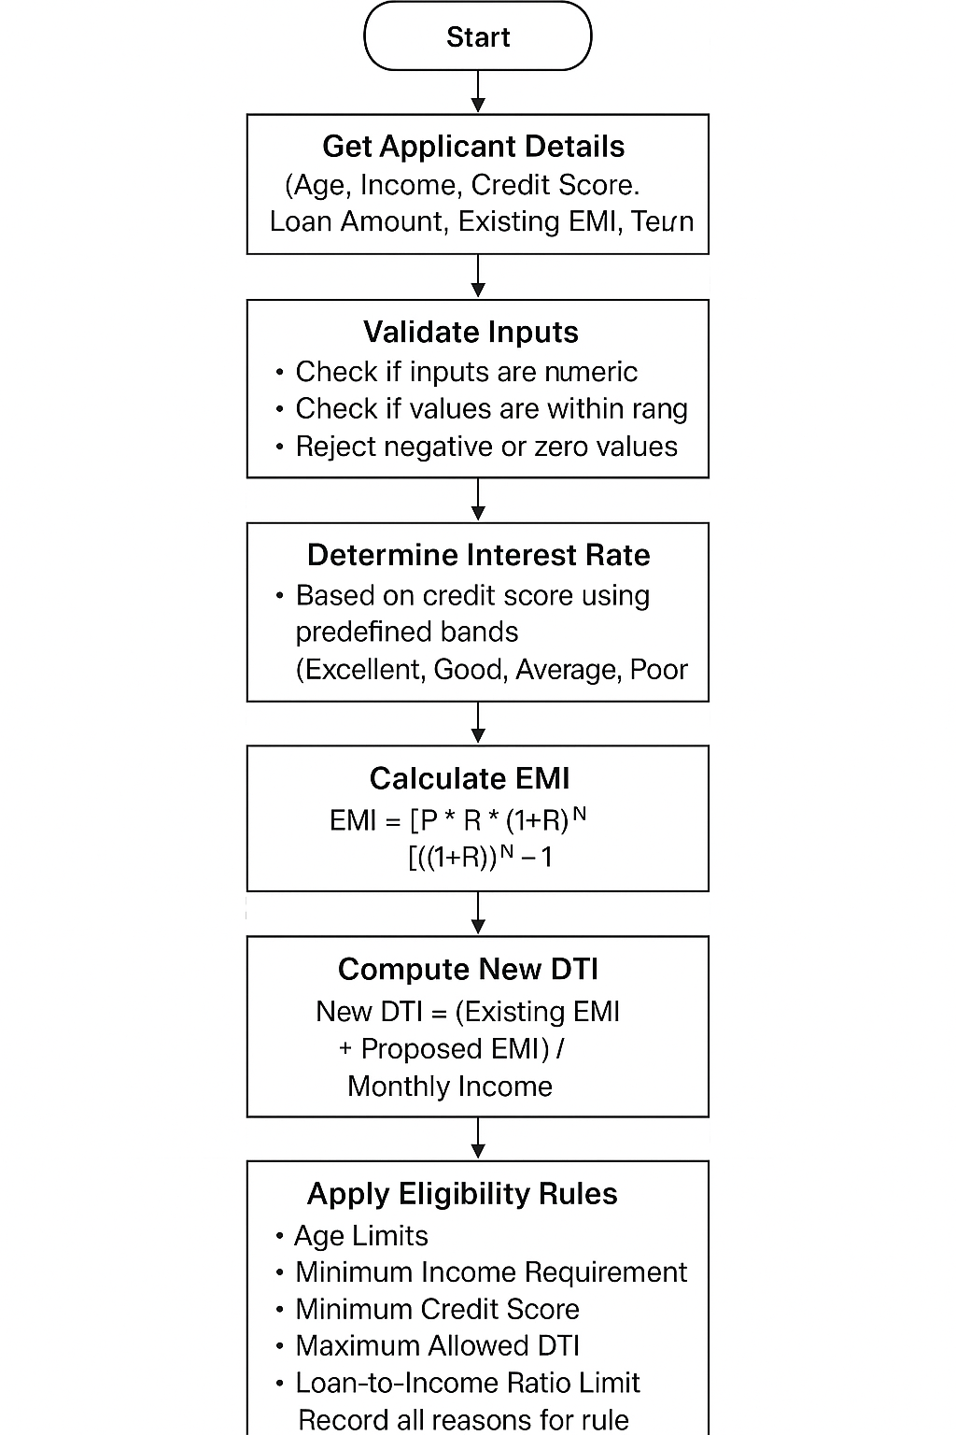
- Output
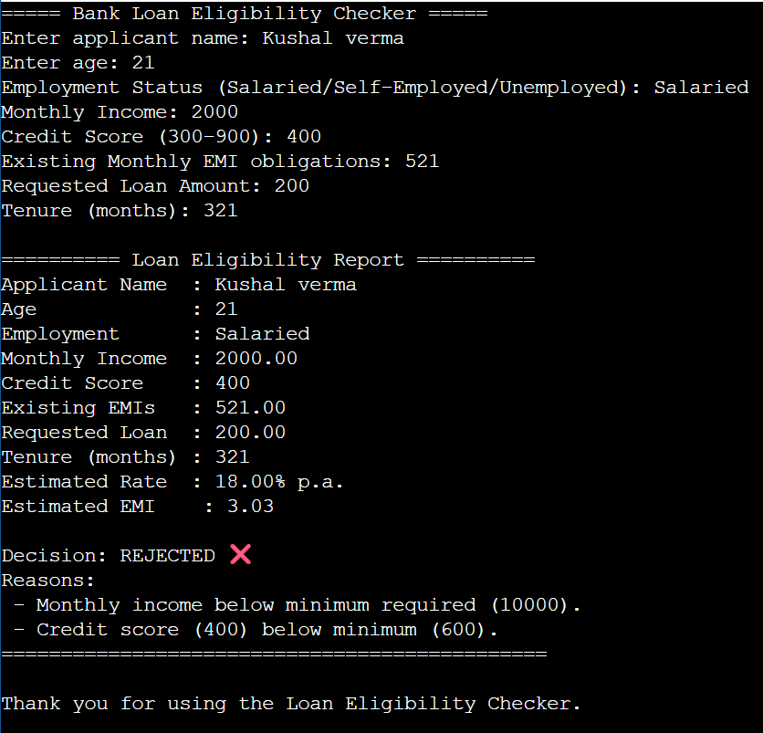

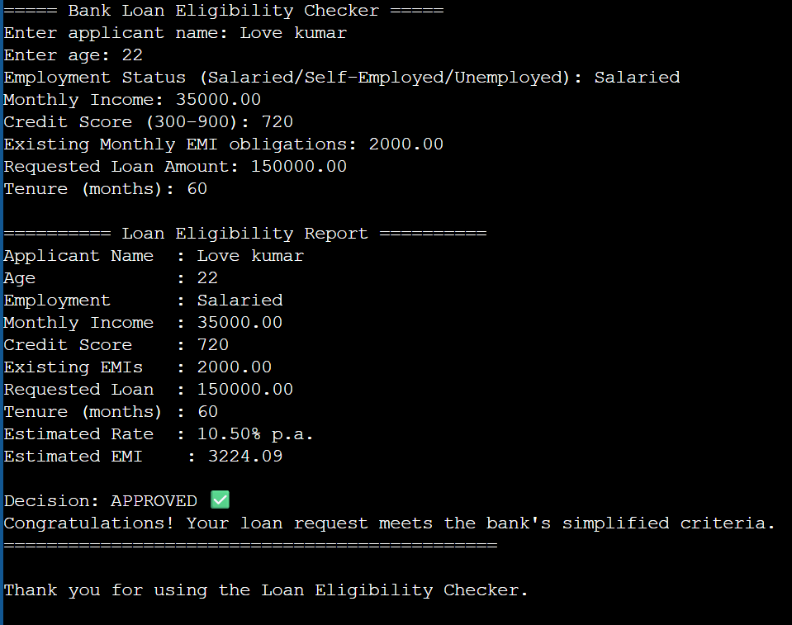

- Acknowledgment
- I would like to express my sincere gratitude to everyone who contributed to the successful completion of this project, “Bank Loan Eligibility Checker using C++.” This project has been an important learning experience, combining concepts from programming, finance, and system design.
- First and foremost, I would like to thank my course instructors for their continuous support, guidance, and encouragement throughout the development of this project. Their teachings on programming fundamentals, structured problem-solving, and software design principles provided the foundation upon which this system was built. The clear explanations and practical examples shared during the course greatly strengthened my understanding of C++ and its real-world applications.
- I would also like to acknowledge the valuable help received from various online learning resources, documentation platforms, and educational websites. These references played an important role in understanding financial concepts such as EMI calculation, interest rate modeling, and basic loan eligibility criteria. Their explanations helped me apply accurate formulas and realistic rules within the program.
- This project is created purely for educational purposes, aimed at improving my understanding of algorithm design, modular programming, and financial computation in C++. It has helped me gain hands-on experience in applying theoretical concepts to real-world-inspired scenarios, and I am thankful to all the sources and mentors who contributed to this learning journey.

- Conclusion
- The Bank Loan Eligibility Checker project successfully demonstrates how fundamental programming concepts can be applied to a practical, real-world financial scenario. By integrating user input, financial calculations, rule-based evaluation, and structured output, the system provides a clear example of how banks assess loan applications using simplified yet meaningful criteria. The project bridges the gap between theoretical learning and practical application, showing how C++ can be used to design systems that mimic real-world decision-making processes.
- Through its modular structure, the project highlights the importance of organizing code into logical units such as input handling, EMI computation, DTI calculation, and rule evaluation. This approach not only improves readability and maintainability but also reflects professional software engineering standards. Students gain experience in designing functions, using data structures like structs, performing mathematical operations, and working with condition-based logic to evaluate complex scenarios.
- The loan eligibility rules implemented—such as minimum income, age range, credit score thresholds, and maximum DTI—serve as an introduction to risk assessment principles followed in actual financial institutions. Although simplified, these rules provide a strong conceptual foundation for understanding how various factors influence lending decisions. The inclusion of EMI and DTI calculations further enhances the financial relevance of the project, demonstrating how numbers influence approval or rejection outcomes.

- Overall, this project is not only a programming exercise but an educational tool that helps students connect software development with financial reasoning. It can be expanded with more advanced features such as amortization schedules, graphical interfaces, automated interest rate models, database integration, or machine learning–based credit scoring. With this flexible foundation, the Bank Loan Eligibility Checker becomes an excellent stepping stone for future enhancements and more sophisticated financial system development.

- References
- GeeksforGeeks. (n.d.). EMI calculation formula and examples. Retrieved from https://www.geeksforgeeks.org
- Gaddis, T. (2019). Starting out with C++: From control structures to objects (10th ed.). Pearson Education.
- Horstmann, C. S. (2021). Concepts of C++ programming. Wiley Publications.
- Schildt, H. (2017). C++: The complete reference (4th ed.). McGraw-Hill Education.
- CLRS. (2009). Introduction to algorithms (3rd ed.). MIT Press.
- Tutorialspoint. (n.d.). C++ programming language basics and standard library. Retrieved from https://www.tutorialspoint.com
- Investopedia. (n.d.). Loan eligibility, credit scoring, and debt-to-income ratio explained. Retrieved from https://www.investopedia.com
- GeeksforGeeks. (n.d.). C++ iomanip library and formatting. Retrieved from https://www.geeksforgeeks.org
- TutorialsTeacher. (n.d.). Vectors, strings, and data structures in C++. Retrieved from https://www.tutorialsteacher.com
- Reserve Bank of India (RBI). (n.d.). Basic guidelines for lending and credit risk assessment. Retrieved from https://www.rbi.org.in
- cplusplus.com. (n.d.). C++ Standard Library: <cmath>, <iomanip>, <string>. Retrieved from https://cplusplus.com

